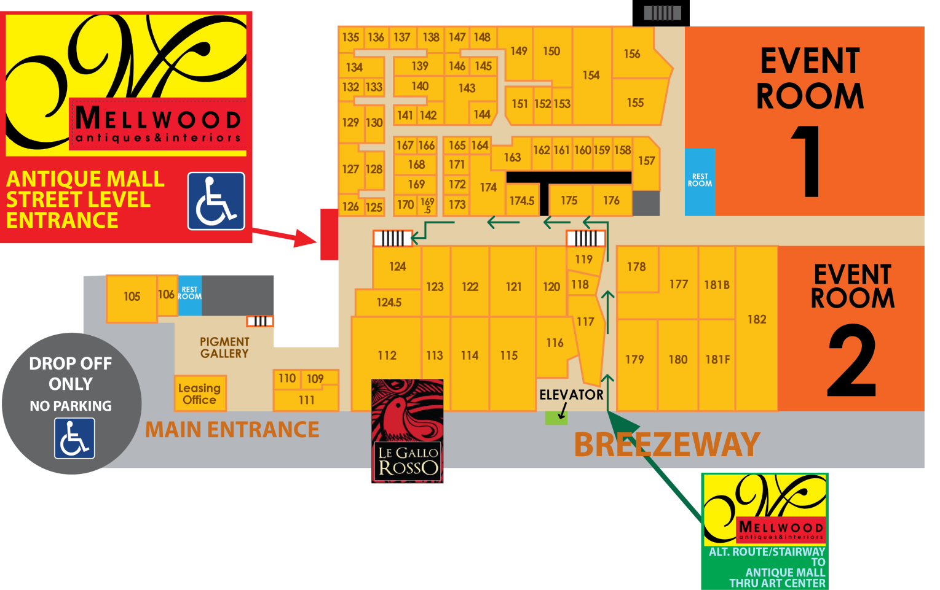

**‘Derby With The Locals’ LIBA Event**

**Is in the Pigment Gallery**

**Mellwood Avenue**

**PARKING**